When the Earth Burns: Wildfires, Carbon, and the Fight for Balance
Every flame that tears through a forest is more than a local tragedy - it is part of a larger story that ties ecosystems, the atmosphere, and our collective future together. Wildfires have always been a natural force of renewal, but today they are increasingly fueled by climate change, leaving scars that stretch beyond charred landscapes. They shape the carbon balance of our planet, reminding us that forests can remain our greatest allies when we protect and restore them.
The Scale of Fire
Over the past decade, the world has seen vast stretches of land consumed by fire, often amounting to hundreds of millions of hectares each year.
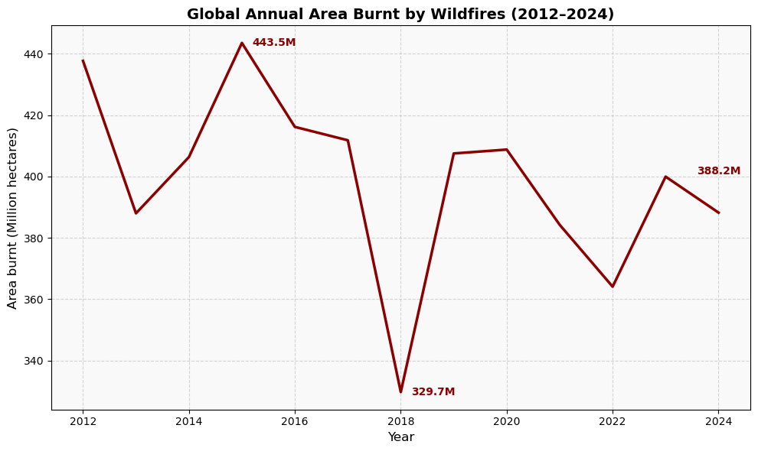
What’s striking is not just the highs and lows, but the persistence: fire has remained a constant player, with 2024 still showing nearly 388 million hectares lost to flames. These are not just numbers - they represent homes for wildlife, carbon sinks for the atmosphere, and safety nets for communities.
Where the Flames Burn Brightest
Some countries bear the heaviest burden. In 2024, the Democratic Republic of Congo, Brazil, and Angola led the world in absolute area burnt. Together, they lost 1.27 million km² - roughly 0.85% of Earth’s entire land surface, consumed by flames in just one year.
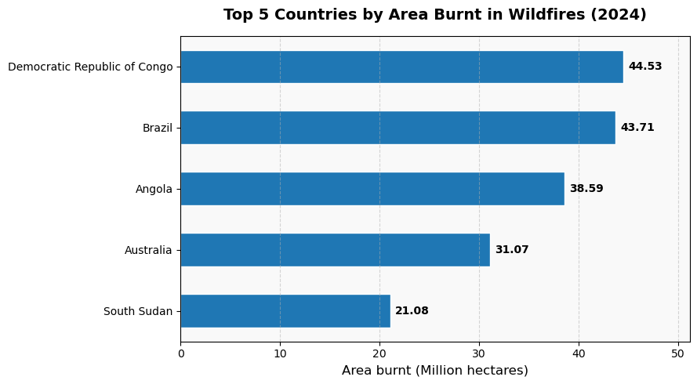
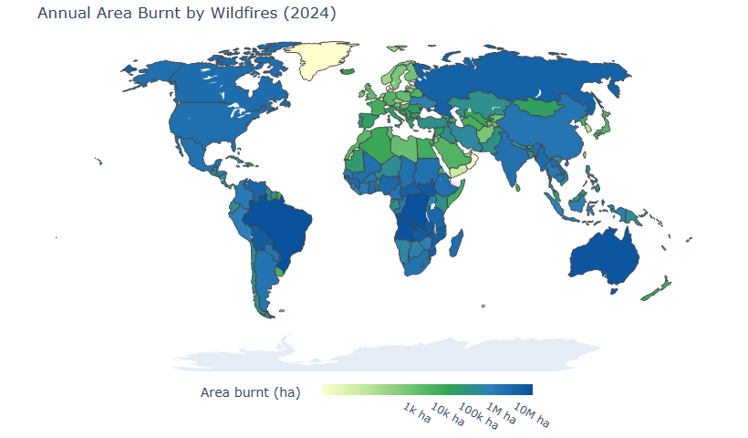
But another way to measure impact is by looking at the share of each country’s land area burned. Nowhere burned more, proportionally, than Laos (17.1%) and Cambodia (15.6%) - where fire touched more than one in every six hectares of land in 2024
Why so high?
Laos and Cambodia stand out with the world’s highest share of land burned because their landscapes are dominated by fire-prone ecosystems—tropical dry forests, wooded savannas, and shifting agricultural mosaics. Here, fire is woven into farming practices, used to clear croplands and refresh pastures. In normal cycles, these fires are seasonal and regenerative, but climate change is stretching dry periods, drying fuels, and intensifying fire spread. Meanwhile, the Democratic Republic of Congo, Brazil, and Angola top the world in total burned area for a different reason: their sheer size and vast expanses of fire-adapted savannas and tropical forest edges. Even when a smaller fraction of their land burns compared to Laos or Cambodia, the result is still tens of millions of hectares lost each year. Together, these two realities - high proportional impact in small nations and high absolute impact in large ones - the dual face of the global wildfire challenge.
Carbon in the Flames
Every hectare burnt releases more than ash - it sends carbon skyward. On average, wildfires have released 6 to 8 billion tonnes of CO₂ each year over the past two decades.
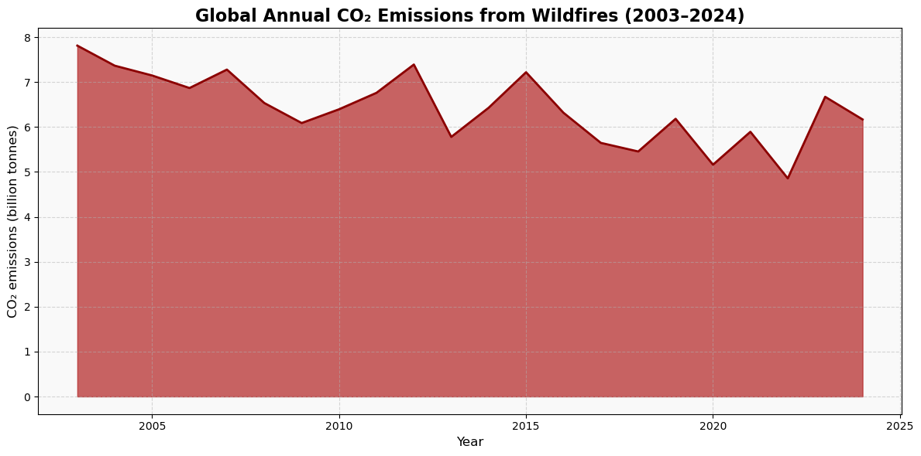
To put this in perspective, global fossil fuel and industrial emissions were about 41 billion tonnes of CO₂ in 2023. That means wildfire emissions account for roughly 15 to 20% of the human-made total in some years.
But here lies the trap: comparing wildfire emissions directly to fossil fuel emissions is misleading. Fossil fuel emissions add carbon that was locked away for millions of years into the atmosphere permanently. Wildfire emissions, by contrast, are part of the short-term carbon cycle - forests can, in theory, regrow and reabsorb much of what they emitted. The danger is when repeated or extreme fires prevent regrowth, turning sinks into long-term sources. That’s why reducing fossil fuel use remains the priority, even as we manage wildfire risks.
Land, Fire, and the Shifting Balance
Wildfire is not uniform - it impacts each continent differently. Africa endures enormous recurring burns across its savannas and shrublands, while Oceania is marked by sweeping grassland fires. Step back to the global scale, and one message emerges clearly: shrublands and savannas dominate the world’s fire activity. Yet even though forest fires account for a smaller burned area, they carry an outsized weight - releasing centuries of stored carbon in a single season.
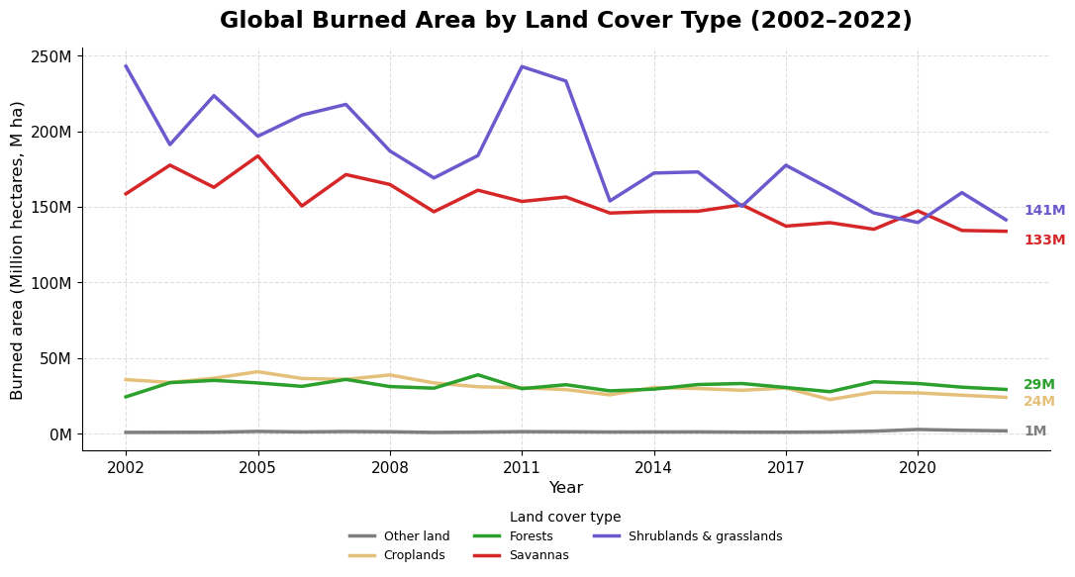
Prescriptions for a World on Fire
The good news is that solutions exist - and many are already being tested. If scaled, they could shift the wildfire-carbon equation back in our favor:
- Smarter Fire Management: Controlled burns, when done safely, reduce fuel buildup and prevent catastrophic blazes.
- Community and Indigenous Stewardship: Indigenous fire practices, especially in Australia and Southeast Asia, show how traditional knowledge reduces destructive fire risk.
- Forest Protection and Restoration: Preventing deforestation in tropical regions locks carbon away, while restoration rebuilds resilience.
- Climate Mitigation: Cutting fossil fuel use reduces the heatwaves and droughts that supercharge fire risks. Unlike wildfire CO₂, fossil fuel CO₂ has no natural “reset.”
- Global Monitoring and Cooperation: Satellites now track burned areas in near real-time. Sharing this data and funding action in fire-prone nations ensures no one faces the flames alone.
A Future Worth Fighting For
Wildfires remind us that the atmosphere and the biosphere are bound together. When landscapes burn, so too does part of our climate security. But when we protect, restore, and manage them wisely, they become shields against a warming world.
This is the hopeful truth: our choices can still decide whether the forests breathe in more than they breathe out.

